RESOLUTION NO.__________

RE: CERTIFICATE OF APPROPRIATENESS UNDER THE
PROVISIONS OF THE ACT OF THE PENNSYLVANIA
LEGISLATURE 1961, JUNE 13, P.L. 282 (53
SECTION 8004) AND BETHLEHEM ORDINANCE NO.
3952 AS AMENDED.

WHEREAS, it is proposed to install signs at 502 E 4th St.
.

NOW, THEREFORE, BE IT RESOLVED by the Council of the City of Bethlehem that a Certificate of Appropriateness is hereby granted for the work.

Sponsored by: (s)

(s)

ADOPTED BY COUNCIL THIS DAY OF

(s)
President of Council

ATTEST:

(s)

City Clerk

HISTORIC CONSERVATION COMMISSION

CASE # 404 – It is proposed to install signs at 502 E 4th St.
OWNER/APPLICANT: Council of Spanish Speaking Organizations/ Lorna Velazquez

The Commission upon motion by Mr. Evans and seconded by Mr. Lader adopted the proposal that City Council issue a Certificate of Appropriateness for the proposed work described herein:

- The proposal to install signs at 502 E 4th St. was presented by Lorna Velazquez.

- The new sign at the Fillmore St. Entrance will be 24” x 24” and read “Fowler Hispanic Youth Center Entrance” with the Hispanic Center full color logo. The sign will have an off-white background. The sign will be mounted on the door with VHB tape.

- The new sign at the 4th St. Entrance will be 30”high x 62.5”wide and read “Fowler Hispanic Youth Center Entrance on Fillmore” with the Hispanic Center full color logo and an arrow. The sign will have an off-white background. The sign will be mounted on the glass above the door with VHB tape.

- The text and graphics will be as shown in the renderings submitted to the HCC, and the colors will be the same as the other signs for the Hispanic Center buildings approved last month.

- Both signs will be fabricated of Diebond, a metal composite material.

- The proposed motion was unanimously approved.

CU: cu

By: 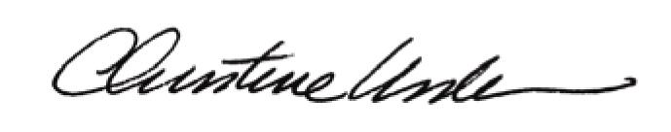

Date of Meeting: February 27, 2012 Title: Historic Officer

